Darius Quick
7/30/25
Module Five Assignment Two
QuestionWithFilter Test Results
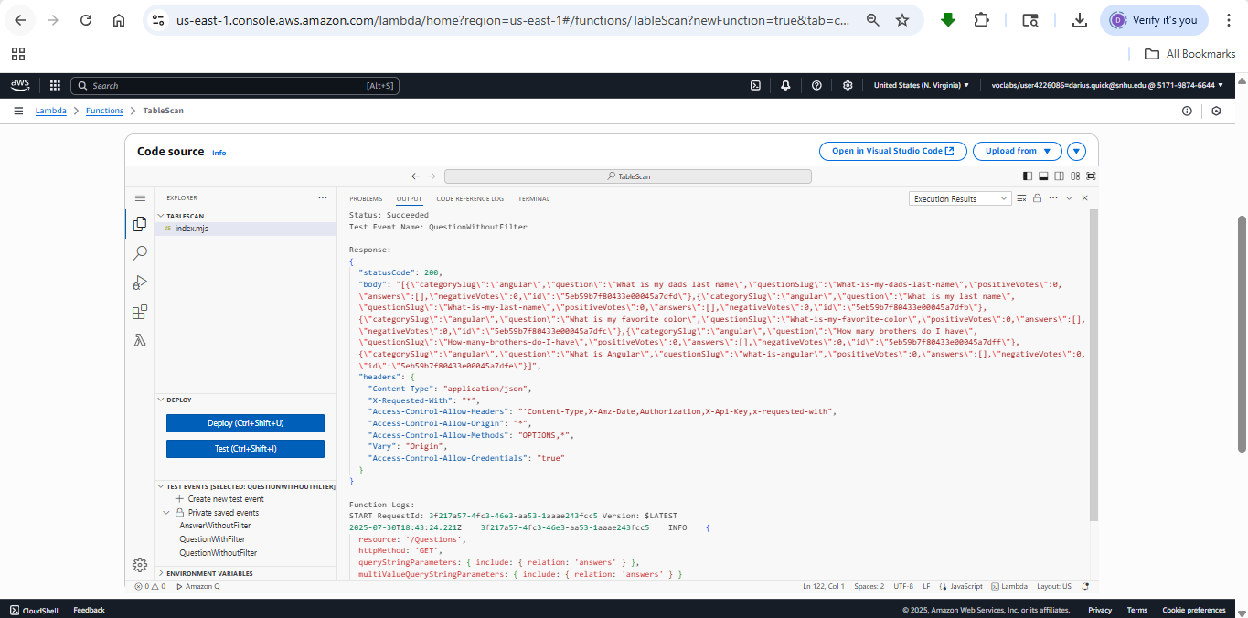
QuestionWithFilter Test Results
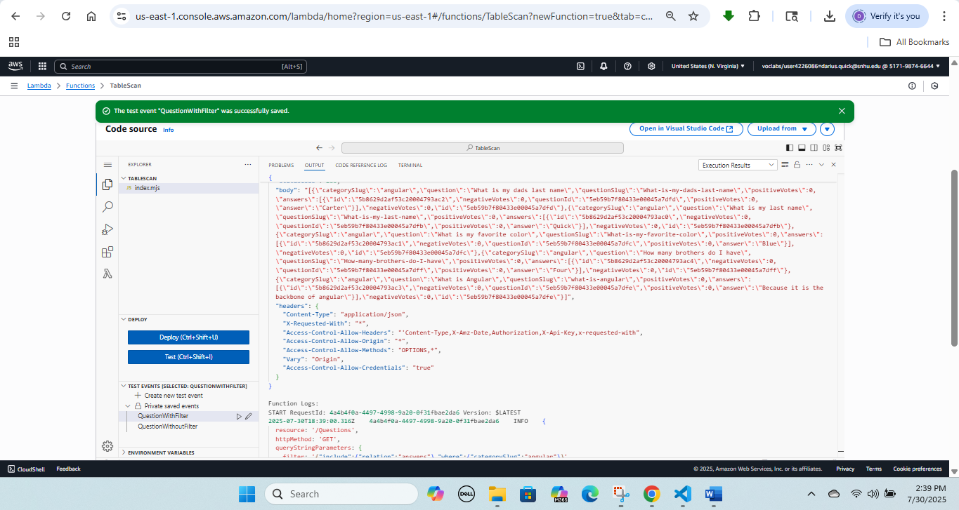
AnswerWithoutFilter
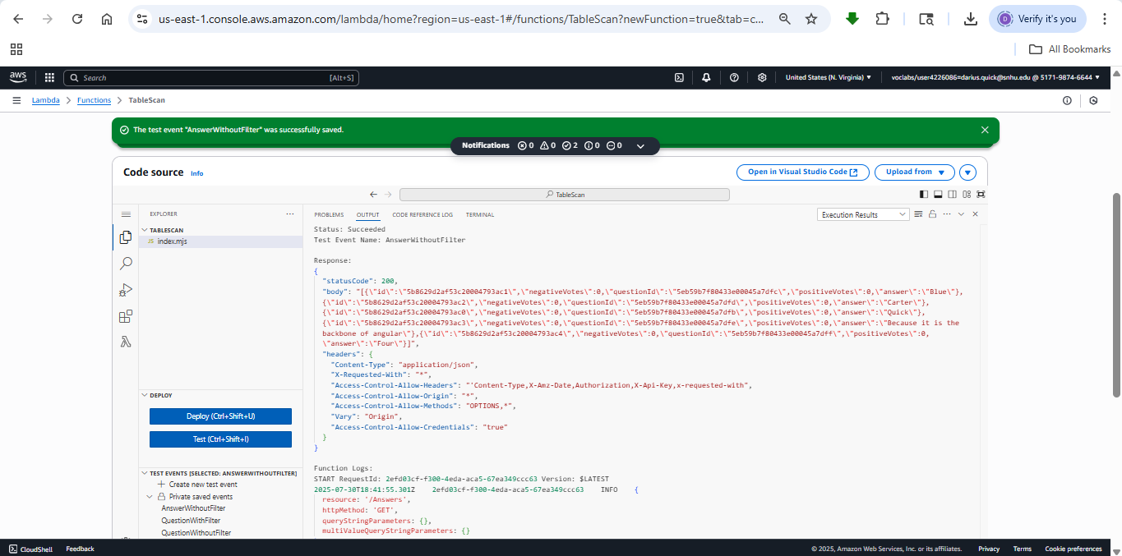
TestGetQuestion Test Results
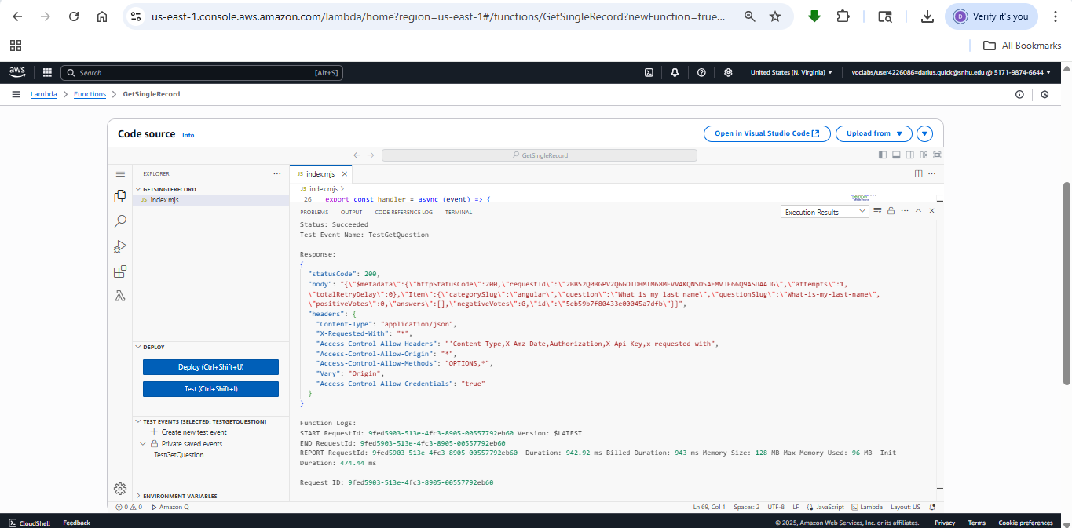
TestGetAnswer Test Results
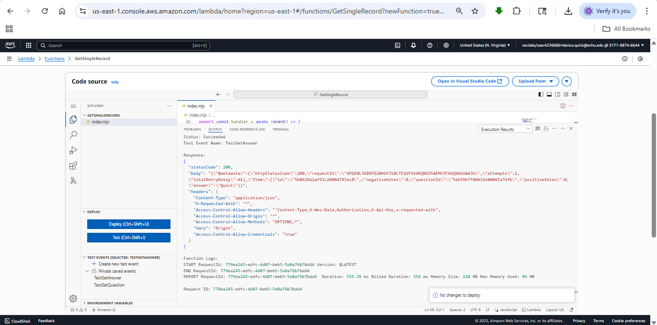
UpsertQuestion Directory Structure and index.js File
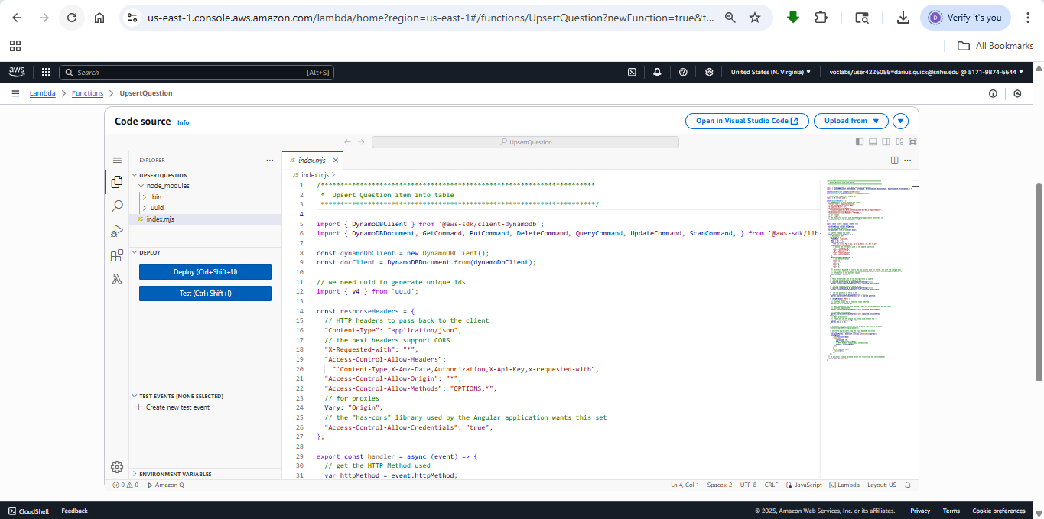
TestInsertQuestion Test Results
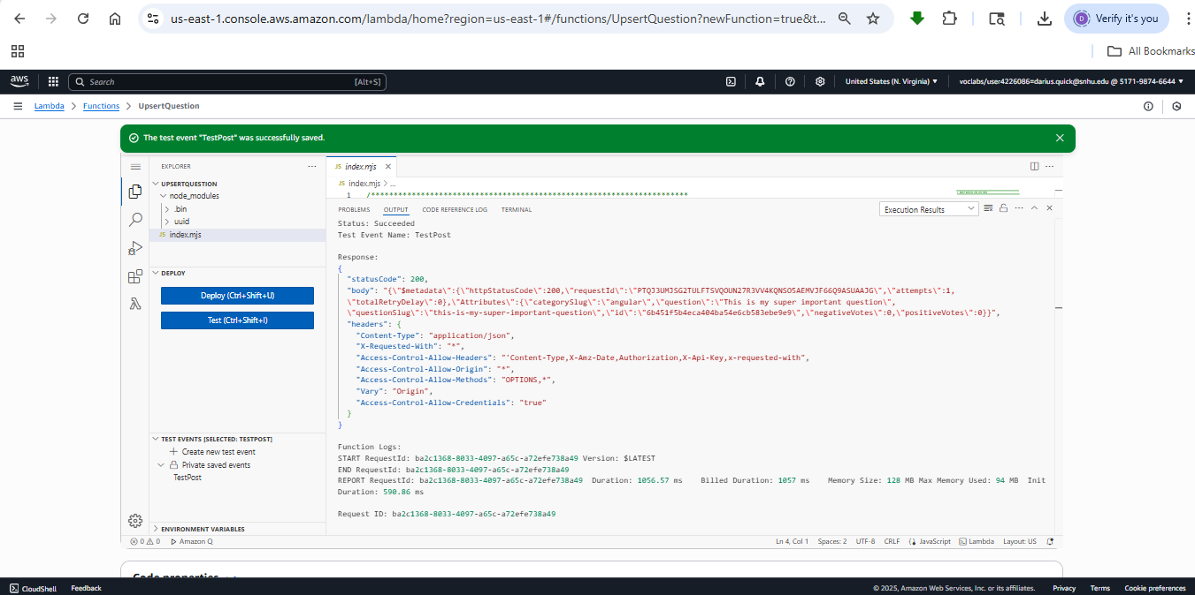
UpsertAnswer Directory Structure and index.js File
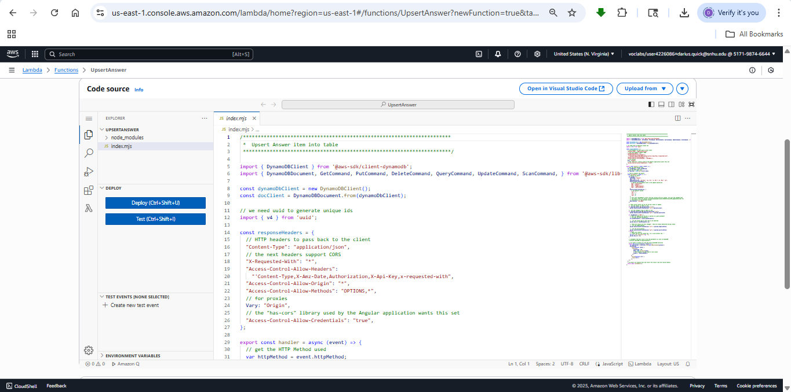
TestInsertAnswer Test Results
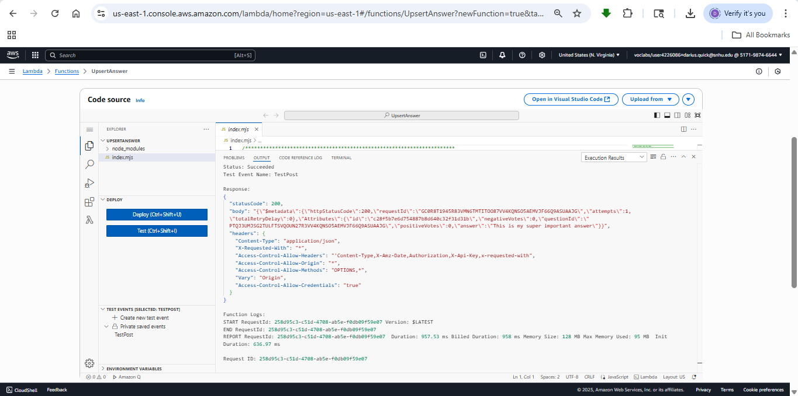
TestDeleteQuestion Test Results
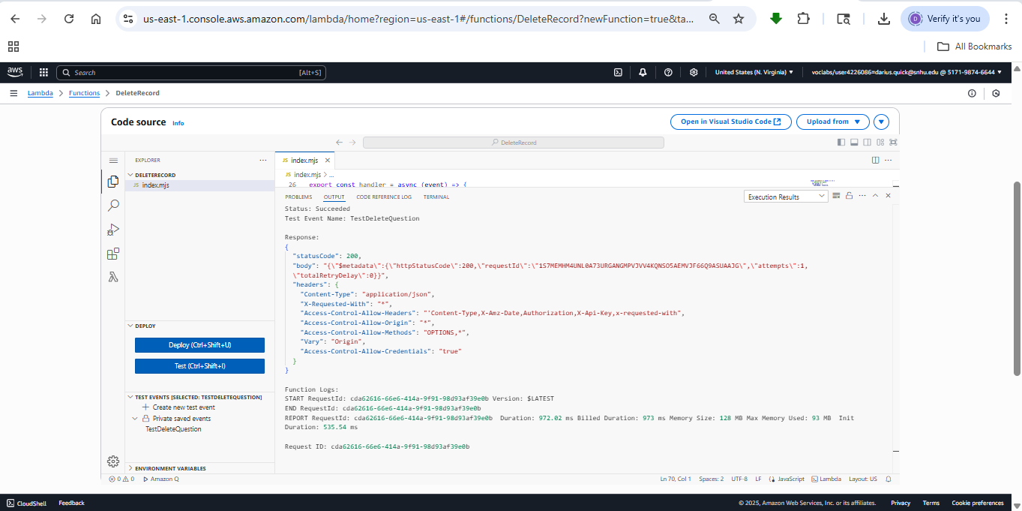
TestDeleteAnswer Test Results
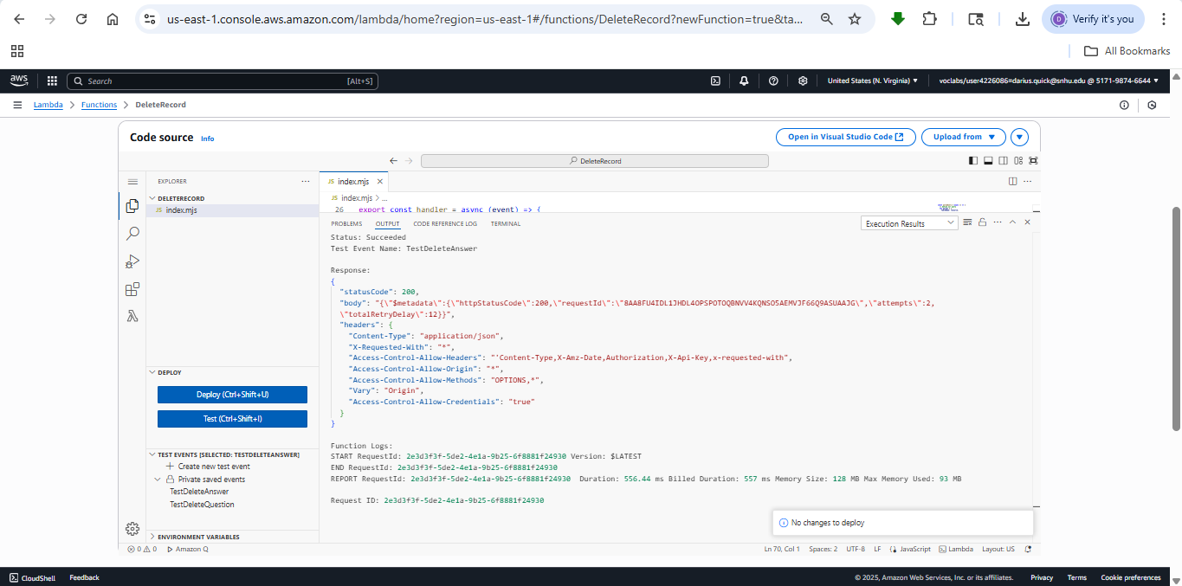
Recreated Question Image
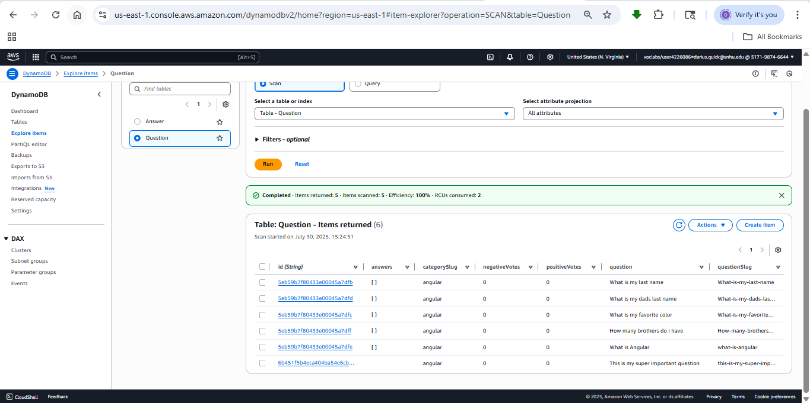
Recreated Answer Image
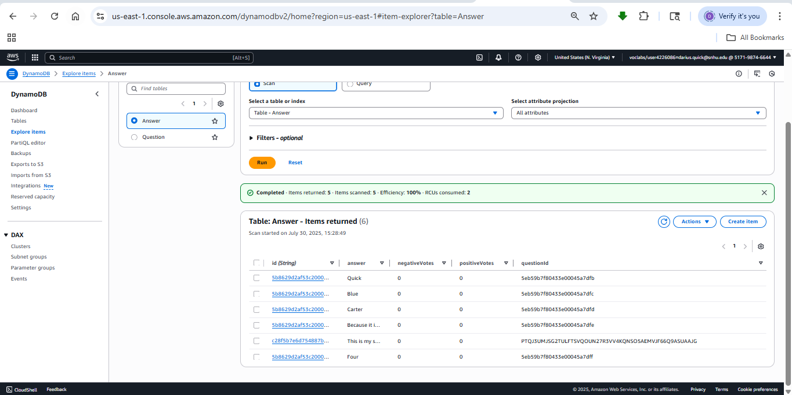
JSON Policy
